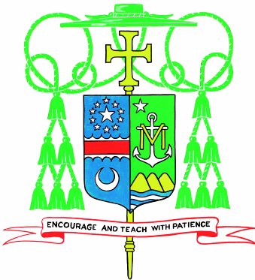

Dear Parents,

I thank you for considering for your children the rich Catholic education that more than 17,000 students are receiving this year in the Diocese of Arlington. The faith formation provided by a Catholic school is distinctive because it is sustained. Students not only receive daily a strong academic education, but also catechesis in their faith and an opportunity to be prepared for and regularly take part in the sacraments. For five days each week, students are immersed in academic education and faith development.

Undoubtedly, you will find your local Catholic school to be a caring, safe and academically challenging environment for your children. Recently, Pope Francis addressed students saying, “…school is one of the educational environments in which we develop through learning how to live, how to become grown-up, mature men and women who can travel, who can follow the road of life” (cf. Pope Francis, 7 June 201e, Address of the Holy Father to the Students of Jesuit Schools in Italy and Albania). Echoing the Holy Father’s sentiments about the immense value of Catholic education, I urge you as parents, the primary educators of your children, to discover the gift of Catholic education. You can give your children no better gift than the ability to be formed fully as a person (mind, body and soul) so that they can live life here with true purpose and life forever after we pass over to God.

I sincerely hope that we will have the opportunity to welcome your child for the upcoming academic year. I believe in the educational mission of the Catholic Church and that your son or daughter will grow and mature through the formation he or she will receive in one of the many Catholic schools in the Diocese of Arlington.

Faithfully in Christ,

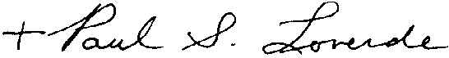

Most Reverend Paul S. Loverde
Bishop of Arlington

